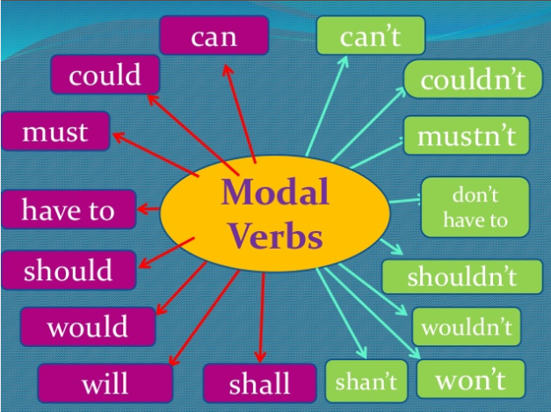

Modal verbs give degrees of possibility and ability.
Should is not as strong as must
Might is not as strong as will

