To the

**Rhyme**

**Chop Chop**

Chop, chop, choppity chop,

Chop off the bottom and chop off the top.

What there is left we will put in the pot.

Chop, chop, choppity chop.

Stir it round, stir it round,

Taste and see what you have found!

**Knowledge and Understanding of the World and Technology**

I have sent home two sheets entitled ‘Our World’ and ‘Technology’ with the children for you to fill out with your child over the next few weeks. Please return the sheets to school when they are completed so we can put them on Tapestry.

**Don’t forget….**

* Please bring PE kit into school in a bag on Wednesday.
* PE kit needs to be worn on a Thursday.
* To hear your child read every evening. Children who are heard read daily at home make good progress with their reading.
* To bring in any materials suited to junk modelling.

**Have a wonderful weekend.**

**Mrs Burrough**

**Robin Class News**

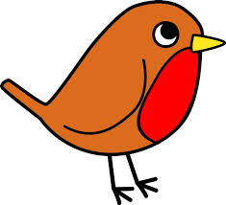

**Year Reception**

**How you can help your child with mathematics.**

This week we have been learning to add one or two to a number by counting on.

When you do the shopping, ask the children to count out the fruit or vegetables into the bag. Or play shops at home. Ask them questions like, if I put one more in, how many will there be then? How about if I put 2 more in? What would be one more than 5? What would be two more than 5? You have only got 6 oranges in your bag, you need 8. How many more do you need to put in so you have 8 oranges?

Keep pointing out numbers to children when you are out and about. If your child likes playing on a computer for a little while, Top Marks has some good maths games on that help children with number recognition, counting, ordering numbers etc.

**How you can help your child with English.**

* Please make time every day to hear your child read. Explain the meaning of unknown words.
* Practise writing the letters learnt so far.

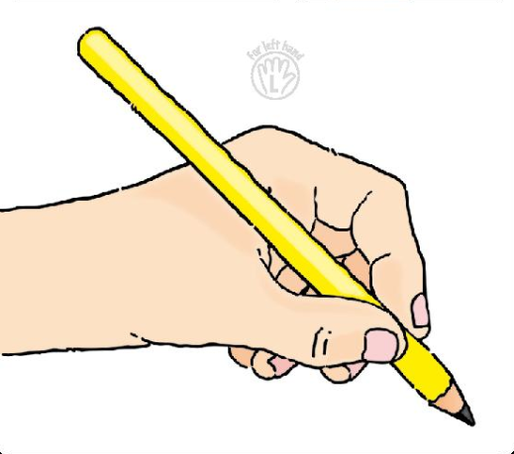 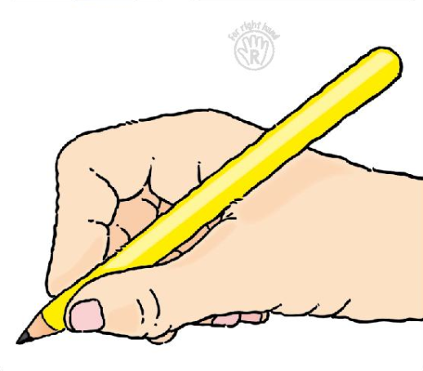

* Please help your child **practise writing their name** starting the lowercase letters from the line.
* Read a story every evening to your child.
* Visit your local library.

**Phonics work week beginning 3rd February 2018.**

In phonics we are moving on to week 4 of phase 3 of letters and sounds. We will be learning the phonemes (sounds):

ng,and the two sounds together, nk

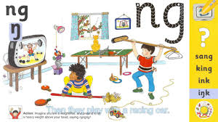

long, song, sang, ping, pong, ring

link, bank, tank, bunk, sink, rink, pink, sunk, honk, chunk

We will also be learning about which letters are the vowels and which are the consonants.

We will practise reading high frequency words learned so far, read and write sentences using letters learned so far as well as the words so, no, go, the, and, to, I.

We will learn to read the high frequency words:

see and my