|  |
| --- |
| **Key Vocabulary** |
| *Inspirational*  If something is inspirational;, it gives you an idea to do something |
| *Community*  The people around us who have something in common |
| *Apostle*  One of the chief disciples of Jesus Christ |
| *Scripture*  Sacred writings of a religion – Christianity or other |

When Jesus started his ministry (mission) he attended the synagogue in his home town of Nazareth. He was given the privilege of reading from the scripture and he selected a reading from the prophet Isaiah. This particular reading became the main point of his mission during his teaching and preaching.

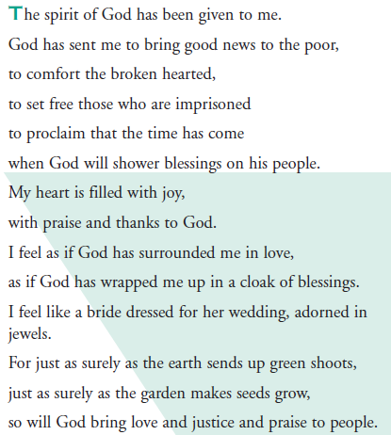

This scripture was the main point of Jesus’ mission – his purpose. We are going to make links between this and Elly’s mission.

**2 – Good News for the Poor**

What does *inspirational* means?

What does *community* mean?

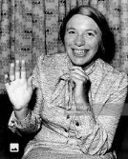

We have looked before at the words of Bless john Henry Newman (everyone has been created for a special reason) – what was God’s reason for Elly’s creation? What have you been created for?

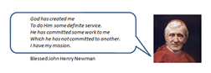

**1 – Inspirational Communities**

Local Church - Community – Year 5 / 6

Elly Jansen was an inspiration person who did something special to help people in her community.

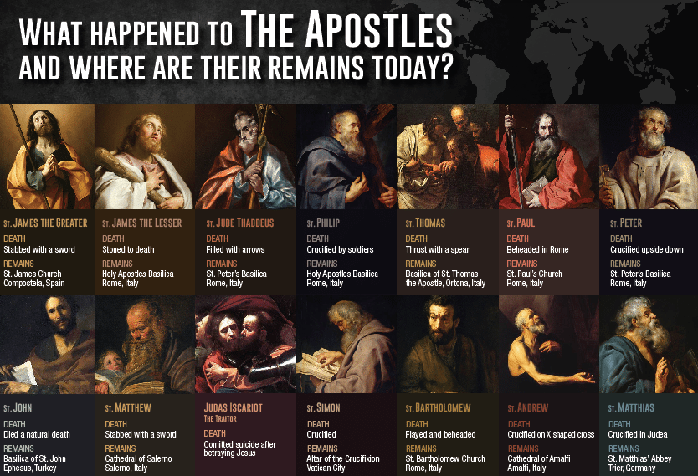

**3 - May They All Be One**

People who were inspired to follow Jesus and to share in his mission began to be called *Christians*. They were led and guided by the 12 apostles, who were called by Jesus to proclaim God’s love and forgiveness *for everyone* by what they said and what they did. This was not an easy task. Sometimes there were disagreements about how they should do this, but they resolved their difficulties through prayer and by remembering what Jesus had taught them. One of the problems came when some of the apostles thought that any person who wanted to follow Jesus, and become a Christian, had to become Jewish first. Each of the followers of Jesus had a different way of encouraging people to follow him. Some focused particularly on Jewish people, others like Paul went to the Gentiles, but each one was spreading the Good News of Jesus’ love. Jesus wanted his followers to live in unity with him and each other.

############

The Bible contains different styles of writing. The New Testament contains lots of letters.

Paul was a busy letter writer. He wrote letters to many of the early Christian communities before, and sometimes after, he visited them. He wrote to explain his understanding of the Christian faith and its practical implications for the lives of Christians.

The Old Testament of the Bible contains the same books as the Jewish holy book – the Torah.

The Holy Spirit is seen as the author of the Bible because He inspired all the authors with their writing.

**6 - New Testament Books: Acts / Letters / Revelation**

**5 – All About The Bible**

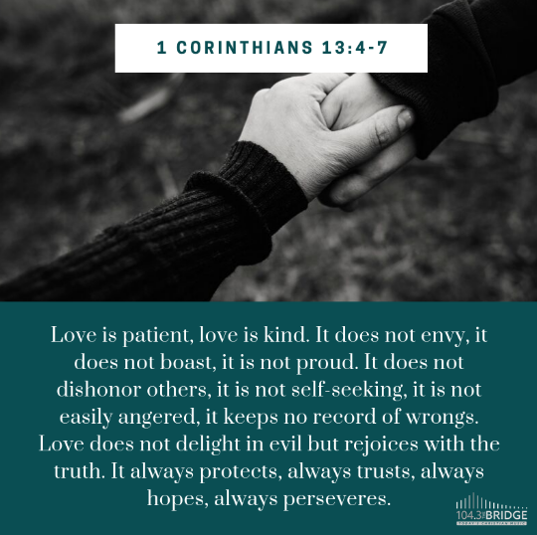

*The Bible is divided into two sections:*

***The Old Testament*** – texts written before Jesus Christ was born and covering God’s dealings with the ancient Hebrew world and its people.

***The New Testament*** – writings following the death of Jesus and covering his life and teaching, the establishment of the Christian church, and letters from church leaders.

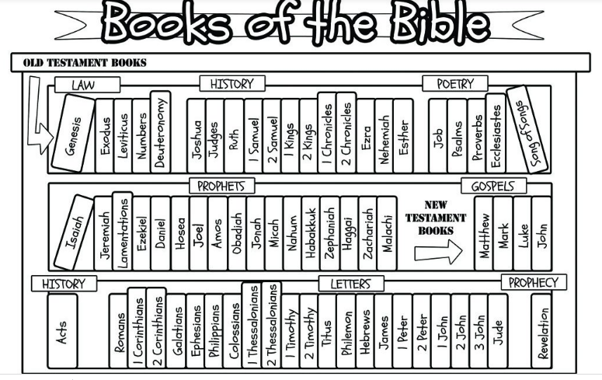

Will Kindles or electronic books ever completely replace actual book? Is a Kindle a book or not? What makes a book a book? What are the pros and cons? Is it possible to imagine a world without books? How do books enrich our lives, whether they are electronic or hard copies, how they can take us beyond our environment and our own thoughts and ideas?

   

How do you prefer to read? Kindle, iPad / tablet, mobile phone or a paper book? Why?

Why would paper books have been so expensive hundreds of years ago?

**4 – A wide variety of books and the purpose for which they were written**