Wednesday 24th June
Please find attached the work for today with all of the extra activities we will be doing in school.
After we have registered we are going to be looking at our phonics sounds. We will practice all of phase 3 and 5 sounds using Flashcard speed trial. Then we will be looking at our tricky words using trick word trucks for phase 5. Below are then the worksheets we will be working through as a class or doing similar activities.
After phonics we will be going out and doing 15 minutes of exercise either playing a game like Simon says outside or super movers.
In maths we will be starting each lesson with using our number square to practice counting forwards and backwards in 2,5 and 10 up to 100. We will then play a game involving finding and making 2digit numbers. We will also practice writing our number 0-6 in words. After this we will be working through the sheets below or doing similar activities using resources.
We will then have half an hour to eat a piece of fruit and have some fresh air outside.
After break it will be literacy. This week we are focussing on Goldilocks and the three bears. Today the children will have the chance to rewrite the story in their own way in their books. They will use this matt to help them as well as their sound cards and word matts.
Following this we will do a go noodle or some super movers.
The children will then work through the following sheets so that we can prepare the classroom for lunch.
We will now have our lunch and fresh air outside.
After lunch the children will have handwriting practice. Today the children will be practicing: Thursday, Friday and Saturday
Then they will have PE. In PE today we will be where they will practice their ball skills.
After this we will have our creative lesson which is art. In art they will be designing their paper plate sea creature that they will be making next week. Here are examples of ones they can use to help them.
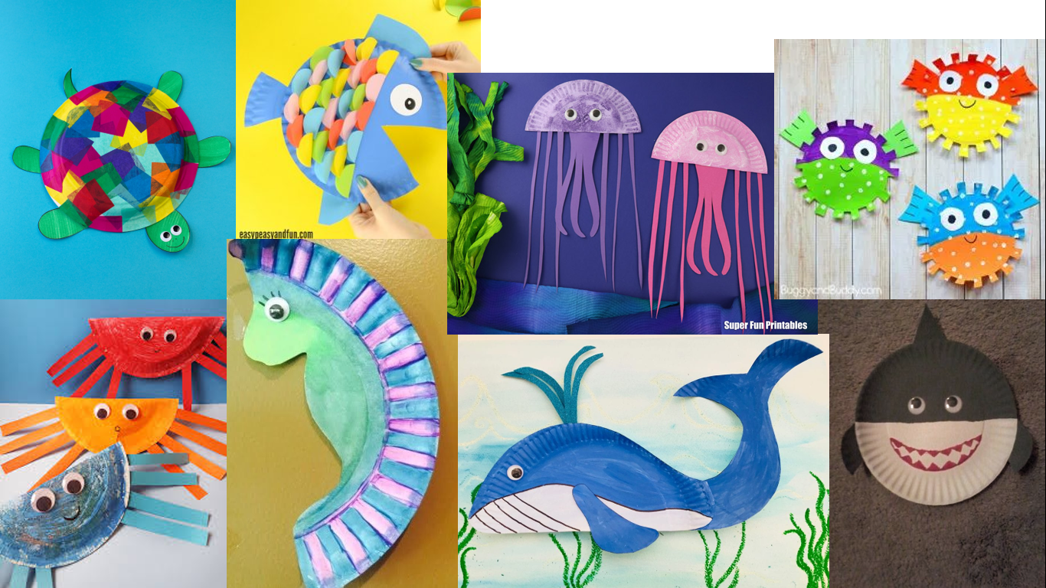

Finally, we will end the day with a story.

